**BAHRIA UNIVERSITY (KARACHI CAMPUS**)

**Discrete Structures (CSC-115)**

**Assignment 04**

**Spring 2023**

**Class: BSE 2B Shift: Morning**

**Course Instructor: ENGR. FAIZ UL HAQUE ZEYA Due Date: 15 June 2023**

**Assignment Date: 09 June 2023 Marks: 05 Points**

**Student Name: ABDULLAH Registration #: 81962**



Question 01: Among 40 patients admitted to a hospital, 20 are diagnosed with pneumonia, 15 with bronchitis, and 10 with both pneumonia and bronchitis.

Determine:

1. The number of patients diagnosed with pneumonia or bronchitis (or both).
2. The number of patients not diagnosed with pneumonia or bronchitis. (**2 marks**)**.**

Answer:

Data:

n(N) = 20

n(B) = 15

n(N and B) = 10

Solution:

Using addition rule

n(N or B) = n(N U B)

= n(N) + n(B) - n(N and B)

= 20 + 15 - 10

= 25

Question 02: How many password combinations are possible with upper- and lower-case alphabets and digit with one digit should be present. The length of password can be from 6 to 8 characters. (**1 mark**)**.**

Answer:

Data:

Total upper letters = 26

Total lower letters = 26

Total digits = 10

Solution:

There are 62 possibilities for each character (26 uppercase letters + 26 lowercase letters + 10 digits).

The number of combinations for a 6-character password is 3 * 62^5.

The number of combinations for a 7-character password is 4 * 62^6.

The number of combinations for an 8-character password is 5 * 62^7.

Total combinations:

= (6-digit passwords) + (7-digit passwords) + (8-digit passwords)

= (3 * 62^5) + (4 * 62^6) + (5 * 62^7)

Question 03: There are 6 people who want to use an elevator. But there is space for only 4 people. How many ways can 6 people try to fill this elevator (one at a time)? (**1 mark**)**.**

Answer:

Data:

Total persons = 6

Total persons at elevator = 4

Solution:

It is a case of combination where order doesn't matter.

Total ways = 6C4

C (6, 4) = 6! / (4! * (6-4)!)

= 6! / (4! * 2!)

= (6 * 5) / (2 * 1) = 15

Question 04: Find shortest distance only from node S to all nodes using Dijkstra’s Algorithm. (**1 mark**)**.**

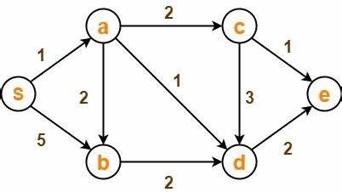

Solution: